
Prairie Smoke Burn Packet for Landowners

This packet contains information for landowners about how to get prescribed burn assistance from Prairie Smoke. Prairie Smoke is a 501(c)(3) non-profit volunteer organization.

Prairie Smoke does not conduct prescribed burns for landowners. We do, however, provide training to landowners on how to conduct their own prescribed burn, we loan equipment to members for conducting prescribed burns, and our members volunteer to assist landowners with their own burns.

Note: Many new Prairie Smoke members have joined in order to learn about
and gain experience with prescribed burns. Prairie Smoke encourages
members planning a burn to welcome other members to participate or observe
their burn.

Prairie Smoke does not have insurance that covers prescribed burns in the event something goes wrong. A landowner using Prairie Smoke equipment or Prairie Smoke volunteer assistance to conduct a prescribe burn or other management activity must sign a waiver acknowledging sole responsibility and liability for their private burn or activity, and indemnifying and holding harmless Prairie Smoke, and its volunteers, of liability for property damage or personal injury as a result of using Prairie Smoke equipment or volunteers.

Liability for conducting a prescribed burn on your property lies with you, the landowner.

Your owner’s liability or hazard insurance coverage, if you have it, may or may not provide insurance coverage. You should verify that you are adequately insured for this activity.

Burn Packet Contents

- Liability Waiver
- Preparing your land for a prescribed burn
- Establishing fire breaks
- Landowners Responsibilities for Conducting a Burn
- Burn Plan form
- Burn Plan example
- Instructions on where to get a burn permit
- Prescribed burn checklist
- How to activate your burn permit, contact list for who to notify prior to a burn

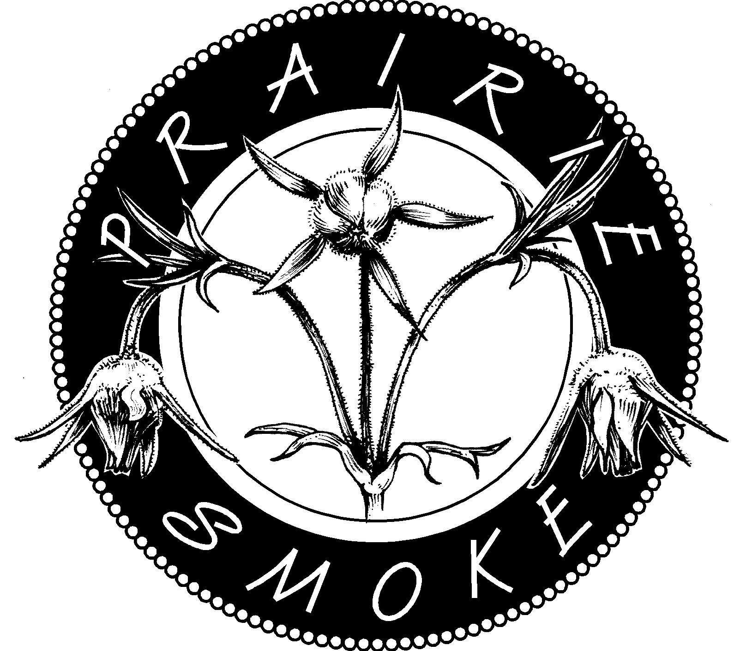 |  | Prairie Smoke Liability Waiver
Prairie Smoke (Lender) agrees to loan equipment to the Prairie Smoke member (Member), provided the member agrees to the terms and conditions specified herein.

Please print clearly
Name of Person borrowing equipment (First, M.I. Last) |  |  |  |  |  |  | Home Telephone No. (include Area Code)
Address |  |  |  |  |  |  | Work Telephone No. (include Area Code)
City, State and Zip |  |  |  |  |  |  | Date (month, day, year)

Equipment covered by this agreement
 | Bladder bag |  | Drip torch | Pulaski |  | Spray equipment |  |  | Water wagon
 | Brushsaw |  | Hard hat/ Kevlar chaps | Rake /Swatter |  | Torch fuel can |  |  | Weather kestrel
 | Chainsaw |  | Parsnip Predator | Seed Collector |  | Two-way radio |  |  | Weed Wrench

Terms and Conditions
Intended Use and Lender Mission: Equipment owned and maintained by the Lender is intended to be used to preserve, enhance or restore prairies, oak savannas or other fire-dependent habitats on public and private lands. The Lender reserves the right to refuse to lend any equipment if, in the judgement of the Lender, the intended use is not in accordance with Prairie Smoke’s mission or if it otherwise appears that lending the equipment would not be in the best interest of Prairie Smoke. The mission of the Lender is to be an educational and management resource to landowners and public land agencies to benefit prairie and savanna protection and restoration, and to increase awareness of the value and rarity of these ecosystems in southeastern Minnesota.

Limitations on use: Member agrees not to use any equipment borrowed from Lender for commercial purposes or to commercially sell any seed harvested with Lender’s equipment. Member will not use burn equipment to burn garbage, leaves, woodpiles not associated with habitat restoration, or to accomplish any purpose not related to protecting, enhancing or restoring prairie, oak savanna or other fire-dependent habitat.

Knowledge and Experience of Borrower: The Member warrants and represents that he or she:
- Is aware of the dangers and risk involved with using fire and the equipment used to conduct a controlled burn.
- Has basic knowledge of controlled burning and proper wind and humidity levels for a safe controlled burn.
- Has participated in at least one prescribed burn.
- Has attended a Prairie Smoke, or Prairie Smoke approved, burn class, equipment demonstration and/or training session at least once prior to use of equipment.

Responsibility for loss or damage to borrowed equipment: Member agrees to be solely and absolutely liable for loss or damage to borrowed equipment and to reimburse Lender in an amount to be determined by Lender for the cost to replace or repair the lost or damaged equipment. Member agrees further to pay all costs of collection reasonably incurred by Lender, including attorney’s fees.

Liability for damage to property or personal injury or death: Member agrees to be solely responsible for monitoring and controlling the intended activity and shall be solely liable for any damage to real or personal property, bodily injuries or deaths resulting from Member’s activity or the use of borrowed equipment while in possession or under the control of Member. Member agrees to hold harmless and indemnify Lender, and its agents and assigns, from any and all claims arising from the use of said equipment, including all costs reasonably incurred, including attorney’s fees, in defending against such claims.

Member understands that Lender, and its agents and assigns, disclaim any liability for any damage to real or personal property, bodily injuries or death as a result of use of borrowed equipment in connection with a prescribed burn or for any other purpose. Loan of the equipment to Member does not create any duty or responsibility of Lender for safe or proper use of the equipment or for any injuries or harm due to unsafe or improper use.
Prairie Smoke Equipment Loan Policy and Procedures

There is no fee associated with the loan of this equipment.
Procedures: In order to ensure equipment availability and the safe, appropriate use of Prairie Smoke equipment, we have established a procedure for borrowing equipment along with a set of criteria members must meet before equipment will be loaned.

There is no fee associated with the loan of this equipment. However, each item requires regular maintenance and periodic replacement of parts or total replacement. Donations from Loanees help offset these expenses and help ensure equipment is available and in good working order for all members. Please consider making a donation to Prairie Smoke. Thank you for your support.

- Members should express an interest for equipment use at the spring or fall burn sign-up meeting or contact the Equipment Coordinator to get put on the list.
- A Prairie Smoke Liability Waiver must be signed, dated and given the Equipment Coordinator each year before equipment will be loaned.
- A member must attend an equipment demo/training meeting or prescribed burn workshop at least once in order to use Prairie Smoke equipment. This will ensure members know how to use equipment and can do general maintenance while the equipment is in his/her possession.
- Member must sign out the equipment in the logbook (at location where equipment stored) when borrowed and sign item(s) back in when returned. The Equipment Coordinator will examine the equipment for damage other than normal wear and tear. If there are problems with the item(s) borrowed, the Member should inform the Equipment Coordinator so they can be fixed.
- Burn equipment must be returned within 3 days of date borrowed and in at least the same condition it was loaned. Non-burn equipment must be returned within 2 weeks of date borrowed. Chainsaws and brushsaws should be sharpened or the blade/chain replaced.
- Equipment using fuel must be returned with the same amount of fuel as when borrowed. All gas/oil mixtures should be mixed according to what is specified in the owner’s manual or equipment fact sheet.

Criteria for use of prescribed burn equipment:
- A member must have participated in a minimum of one prescribed burn before conducting his/her own burn. We are requiring this to help ensure the member is aware of the risks/dangers involved in conducting a prescribed burn and has at least experienced a burn prior to conducting his/her own burn.
- The member must present a valid burn permit issued by the DNR or local burning authority. This is to ensure you have taken the necessary steps for conducting a burn prior to actually performing the burn.
- A member must present a prescribed burn plan that includes all parcels to be burned. For burns larger than 2 acres, we recommend the burn plan include an aerial photo which are available from your local FSA office. This requirement ensures that you have given consideration to safe weather conditions, fire breaks, any hazards your property might have including terrain and fuel types and evaluated the minimum number of people required to carry out your burn.
- A member who is inexperienced with prescribed burning should ask a more experienced Prairie Smoke member(s) to volunteer on his/her burn. A list of volunteers is available from the Prairie Smoke President.

Criteria for use of spray and brush equipment:
- A member must have experience using a gas-powered brushsaw or chainsaw prior to borrowing this equipment. If not, the member must take a training class prior to borrowing the equipment.
- Any person using the brushsaw or chainsaw equipment must wear personal protective equipment during use, which includes safety glasses, leather gloves, a hard hat with face shield, Kevlar chaps that reach the top of your boots, and leather boots that go above the ankle. Hard hats with face shields and chaps are available for loan with the equipment.
- Any person(s) assisting with brush removal must wear a hard hat and safety glasses.
- Any person(s) using spray equipment must follow label instructions for the application rate and target species for the specific chemical used.
- All containers used for spraying must be triple rinsed after each use. The first rinse should include a small amount of soap, with clean water used for the second two rinses. This will prevent corrosion of the washers and seals on the equipment.

Acknowledgement: I have read and understand this waiver. I represent that I am the owner, controller and possessor of the land upon which the borrowed equipment will be used. I also have read and understand the attached Equipment Loan Policy and Procedures, which is hereby incorporated into this agreement by reference. This Liability Waiver shall apply to all activities within the calendar year of signing. I agree to the terms and conditions herein.

You must sign and submit this liability waiver to Prairie Smoke’s Equipment Coordinators (Barb and Walt Nigon; wbnigon@gmail.com) before equipment will be loaned to you. This waiver is effective for one calendar year.
Date:
Member

Preparing Your Land for a Prescribed Burn

- Prepare a Burn Plan: A burn plan identifies the area you plan to burn, establishes safe and desired conditions under which to conduct the burn, and specifies equipment and personnel needs. A burn plan should include an aerial photo or map of the parcel to be burned. Fire breaks and potential hazards should be identified on the photo/map. A Burn Plan template is included in this packet. If you need assistance in preparing your burn plan, you may contact the Prairie Smoke Board.

When determining the area you want to burn, try to keep the burn unit as uniform in shape as possible. This allows for a safer burn. Narrow fingers and complicated edges increase the time required to conduct a burn, and increase the difficulty in controlling the fire.

Weather conditions are important considerations for any prescribed burn. Your burn plan should address wind speed and direction, temperature, and relative humidity. When determining your desired wind direction, you need to consider the area surrounding your burn. A specific wind direction may be needed to avoid putting smoke on a nearby road, farm/house, or to avoid sending a head fire toward adjacent fuel, such as a grass field. Desired wind speed, temperature and relative humidity are typically recorded as acceptable ranges on your burn plan. Most burns are conducted when air temperatures are between 40 – 70 degrees, winds are less than 15 mph at ground level (also called 4’ wind speed), and relative humidity is between 30 – 50%. For safety reasons, burns should not be conducted when ground level wind speeds are greater than 15 mph, and/or relative humidity is less than 25%. There may be certain situations when an increased wind speed is desired, however, you will need very experienced personnel to conduct such a burn.

The size and complexity of your burn, along with the experience level of your crew will determine the amount and types of equipment and the number of people needed for your burn. Burns 5 acres or less typically need 4-6 people, 4 backpack sprayers, two drip torches, two swatters, 4 radios. Larger burns require more people and equipment. If you are uncertain of the number of people and types and amount of equipment needed for your burn, please consult with a Prairie Smoke Board member or an experienced burner.

If you are an inexperienced burner, you need to recruit someone to serve as a “burn boss” for your burn. The Burn Boss is a person with more prescribed fire experience, who is capable of leading a burn and helping direct burn crew members. The Burn Boss does not coordinate your burn in terms of getting equipment to the site and arranging for volunteers, you must do that (see Landowner Responsibilities for Conducting a Prescribed Burn in this packet). You, the landowner, must be present at your burn, even if you are not physically capable of conducting the burn.

- Prepare burn breaks: Once you have determined what area you want to burn, the next step is to determine what you will use for fire breaks and where they will be located. The goal of a fire break is to slow or stop the fire. Breaks can be roads, driveways, trails, water, or anything that would slow or stop a fire. Mowed grass breaks are very common, and can be very effective if prepared properly. Grass breaks should be mowed short, 3” or less, and have little to no duff (dead grass). Ideally grass breaks should be mowed in the fall, which allows them to quickly green up in the spring before the taller grass. Fire breaks should be a minimum of 4’ wide, but wider is preferred. See “Establishing Fire Breaks” article enclosed in this packet. If you are unsure if your breaks are adequate, you can take a picture of them and send them to a Prairie Smoke Board Member to evaluate, or you can ask a member to come to your property to check them. Establishing good fire breaks is critical to having a safe burn. Inadequate fire breaks are often the greatest weakness for many burns.

- Remove or minimize hazards: Hazards are things that are in or adjacent to the area you plan to burn that may create problems during a burn. Hazards can include things such as telephone poles, fences, brush piles, septic tank pipes, pine trees, garbage, standing dead trees, etc. Some hazards, such as brush piles, can and should be removed prior to a burn. Other things, such as fences and telephone poles, cannot be removed. However, they can be mowed around, or excluded from the burn unit if possible. Hazards that cannot be avoided should be identified on your burn plan map/photo, and how they will be treated during the burn should be considered. For example, you may need extra water near fence posts during the burn, which may increase your equipment and/or personnel needs.

Developing a burn plan, establishing good fire breaks, and removing or minimizing hazards are the three main components to getting your property ready for a burn. Once you have done these three things, you are ready to set a date for your burn, reserve equipment and start recruiting volunteers to help conduct your burn. How to take the next step is outlined in the “Landowner Responsibilities for Conducting Prescribed Burns”.
Landowner Responsibilities for Conducting a Prescribed Burn

Prairie Smoke

- Prepare a burn plan, prepare burn breaks, and remove or minimize hazards.

- Sign and submit the Prairie Smoke Liability Waiver to Barb and Walt Nigon; wbnigon@gmail.com.

- Get your burn permit for a running fire (see Getting a Burn Permit section of this packet).

- Set a tentative date for your burn, and reserve the burn equipment by calling Walt and Barb Nigon 507-285-0496 or wbnigon@gmail.com The burn equipment is stored on their property. It is the landowner’s responsibility to reserve the equipment, pick up the equipment before your burn, and then return the equipment after the burn. When you pick up the equipment.

When you pick up the equipment, the drip torches and fuel cans should be full. We ask that you replace fuel you use during your burn. The drip torches use a fuel mixture of 1 part gasoline to 3 parts diesel. Fill the drip torches and the drip torch fuel tank. Be sure to put the correct fuel in the marked containers. This way, things are ready for the next user. If you plan to use the burn wagon (portable 200 gallon water tank), which is recommended for larger burns or sites with minimal water access for refilling bladder bags, you will need a vehicle with a 2” ball hitch. The burn wagon pump uses regular unleaded gas. Let Barb or Walt know if there are any problems with the equipment. Please return equipment promptly after use so it is ready for the next user.

- Recruit volunteers and a burn boss to help with your burn. You can call people on the Prairie Smoke volunteer list to see if they are available. Several Prairie Smoke members are willing to serve as Burn Boss if needed; they are indicated on the volunteer list. You can also recruit friends and neighbors to help. It is always better to have too many crew members than not enough. However, be sure to have at least two experienced people on your burn crew for burns 10 acres or less. For burns larger than 10 acres, you should have more experienced crew members. Be sure to give volunteers the following information: day and time of burn, approximate duration of burn (in hours), directions to the burn location, and a phone number where you can be reached. If you have people helping who have not burned before, make sure they wear all natural fiber cotton clothing or wool, leather gloves and boots, a hat, eye protection, and a bandana to protect their face from heat and smoke.

- Have a plan for contacting all of your volunteers the night before or morning of the burn in case you have to cancel the burn or change plans.

- On the day of the burn, you must activate your burn permit by either calling the 1-800 number on the permit, or going on-line. Some communities require you to contact the local fire chief or volunteer fire department, to let them know you are conducting a prescribed burn. Failure to activate your burn permit may result in an emergency vehicle being dispatched to your burn. If this happens, you will be responsible for the cost of the emergency call, which can be as high as $400.

- After all the volunteers have arrived, review your burn plan, and give crew assignments. Make sure everybody understands his or her assignments.

- Start burning. Upon completion of your burn, you should call the County Dispatch to let them know you are finished so they can be certain you are done if calls come in on another fire in your area.

- It’s a good idea to have refreshments for your crew after the burn. For small burns, snacks and drinks are common. For larger burns, consider having burgers or something along with beverages. But be sure the crew isn’t moving on to another burn after yours before doing anything elaborate, as there may not be much time.

- While there is no fee to use the burn equipment, users are encouraged to make a donation to Prairie Smoke to offset maintenance, repair, and replacement costs for the equipment. Also, if you are not already a member of Prairie Smoke, please fill out the attached membership form. Membership is required in order to use the Prairie Smoke equipment.

Send membership forms and donations to:
Prairie Smoke
P.O. Box 1312
Eyota, MN 55934

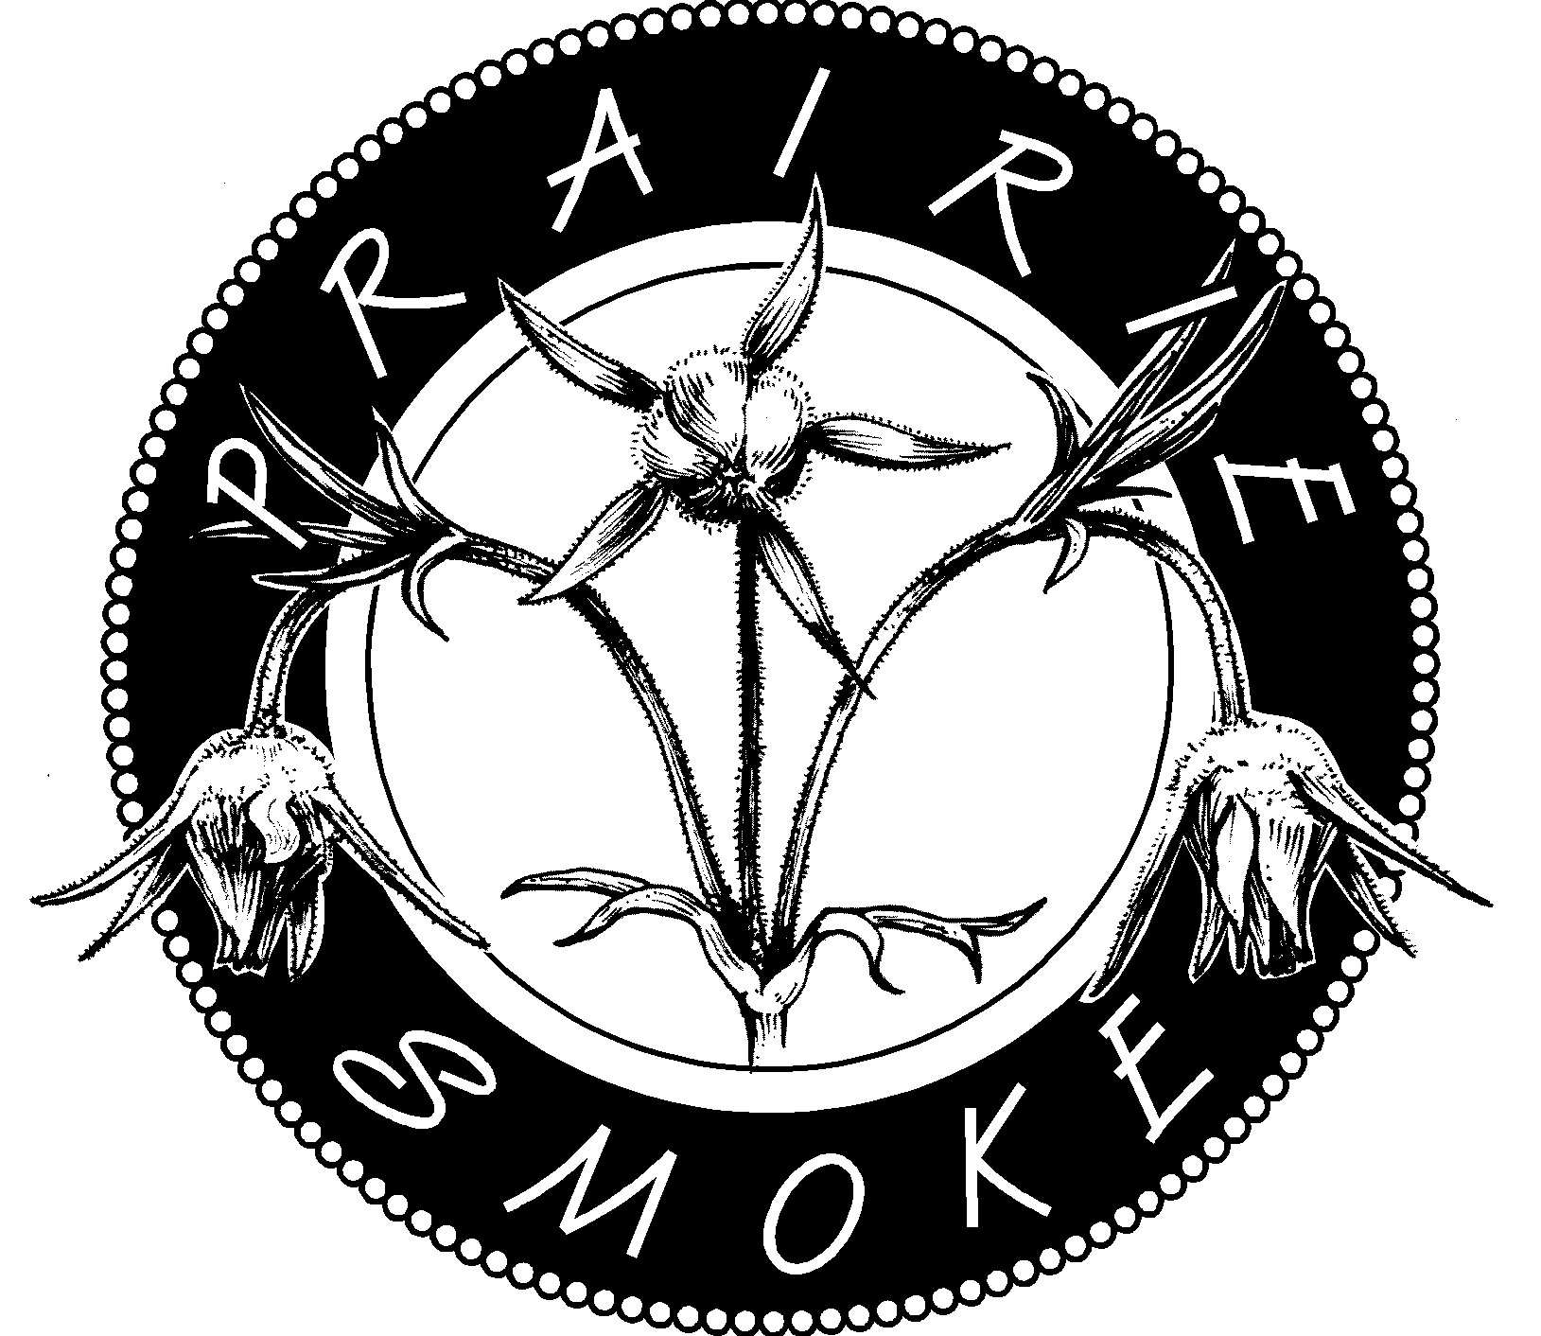 |  |  |  | Prescribed Burn Plan Form
Burn Unit/Landowner Name:
Location: |  |  |  |  |  |  | County |  |  | Town |  |  |  |  | Range |  |  |  | Section
Site Information: |  |  |  |  |  |  | Size (acres) |  |  | Primary Fuel Type |  |  |  |  |  |  |  |  | Terrain
Desired Burn Conditions: |  |  |  |  |  |  | Wind Direction |  |  | % Relative Humidity  Max/Min |  |  |  |  | Wind Speed  20’ / 4’ |  |  |  | Temperature  Max/Min *F
** To get 4’ wind speed for ground level, multiply the 20’ wind speed by .4 (20’wind x .4 = 4’ wind speed)
CAUTION: |  |  |  |  |  |  | - Wind speed at 4’ should never exceed 20mph |  |  |  |  |  |  |  | - Relative humidity should never be below 25%
Crew and Equipment Needs:
Number |  |  |  | Item |  |  |  |  |  |  |  |  |  |  | Number |  | Item
 |  |  | People |  |  |  |  |  |  |  |  |  |  |  |  |  | Hardhats with shrouds
 |  |  | Bladder bags |  |  |  |  |  |  |  |  |  |  |  |  |  | Drip torch fuel can
 |  |  | Drip torch |  |  |  |  |  |  |  |  |  |  |  |  |  | Burn on road signs
 |  |  | Rakes |  |  |  |  |  |  |  |  |  |  |  |  |  | Pulaski
 |  |  | Swatters |  |  |  |  |  |  |  |  |  |  |  |  |  | Chainsaw
 |  |  | Radios |  |  |  |  |  |  |  |  |  |  |  |  |  | Water wagon
 |  |  | Weather Kestrel
*** |  | Attach a map or aerial photo of your burn unit. Mark on it, the direction north, firebreaks and hazards |  |  |  |  |  |  |  |  |  |  |  |  |  |  |  |  |  |  |  | ***
Emergency Contacts:
Fire Dept: |  |  |  |  |  |  |  |  |  |  |  | Neighbors:
Forestry Office:
Medical:
Actual Burn Conditions: |  |  |  |  |  | Wind Direction |  |  | Relative Humidity  Max/Min |  |  |  |  | Wind Speed  20’ / 4’ |  |  |  | Temperature  Max/Min

Date(s) Burned: _________________________________________________________
 |  |  |  | Prescribed Burn Plan Example
Burn Unit/Landowner Name: |  |  |  |  |  |  |  | Smith 2008 planting
Location: |  |  |  |  |  |  | County |  |  | Town |  |  |  |  | Range |  |  |  | Section
 |  |  |  |  |  |  | Fillmore
Site Information: |  |  |  |  |  |  | Size (acres) |  |  | Primary Fuel Type |  |  |  |  |  |  |  |  | Terrain
 |  |  |  |  |  |  | 18 |  |  | Native grasses |  |  |  |  |  |  |  |  | flat
Desired Burn Conditions: |  |  |  |  |  |  | Wind Direction |  |  | % Relative Humidity  Max/Min |  |  |  |  | Wind Speed  20’ / 4’ |  |  |  | Temperature  Max/Min *F
 |  |  |  |  |  |  | E, NE or N |  |  | 30 |  |  | 45 |  | 15 |  | 6 |  | 40 |  | 65
** To get 4’ wind speed for ground level, multiply the 20’ wind speed by .4 (20’wind x .4 = 4’ wind speed)
CAUTION: |  |  |  |  |  |  | - Wind speed at 4’ should never exceed 20mph |  |  |  |  |  |  |  | - Relative humidity should never be below 25%
Crew and Equipment Needs:
Number |  |  |  | Item |  |  |  |  |  |  |  |  |  |  | Number |  | Item
 | 8 |  | People |  |  |  |  |  |  |  |  |  |  |  | 8 |  | Hardhats with shrouds
 | 6 |  | Bladder bags |  |  |  |  |  |  |  |  |  |  |  | 1 |  | Drip torch fuel can
 | 2 |  | Drip torch |  |  |  |  |  |  |  |  |  |  |  | 0 |  | Burn on road signs
 | 2 |  | Rakes |  |  |  |  |  |  |  |  |  |  |  | 0 |  | Pulaski
 | 2 |  | Swatters |  |  |  |  |  |  |  |  |  |  |  | 0 |  | Chainsaw
 | 6 |  | Radios |  |  |  |  |  |  |  |  |  |  |  | 0 |  | Water wagon
 | 1 |  | Weather Kestrel
*** |  | Attach a map or aerial photo of your burn unit. Mark on it, the direction north, firebreaks and hazards |  |  |  |  |  |  |  |  |  |  |  |  |  |  |  |  |  |  |  | ***
Emergency Contacts:
Fire Dept: |  |  |  |  | (507) 765-3874 |  |  |  |  |  |  | Neighbors: |  |  |  | Bob (507) 555-1234
Forestry Office: |  |  |  |  | (507) 765-2740 |  |  |  |  |  |  |  |  |  |  | Jon (507) 555-5678
Medical: |  |  |  |  | 911
Actual Burn Conditions: |  |  |  |  |  | Wind Direction |  |  | Relative Humidity  Max/Min |  |  |  |  | Wind Speed  20’ / 4’ |  |  |  | Temperature  Max/Min

Date(s) Burned: _________________________________________________________
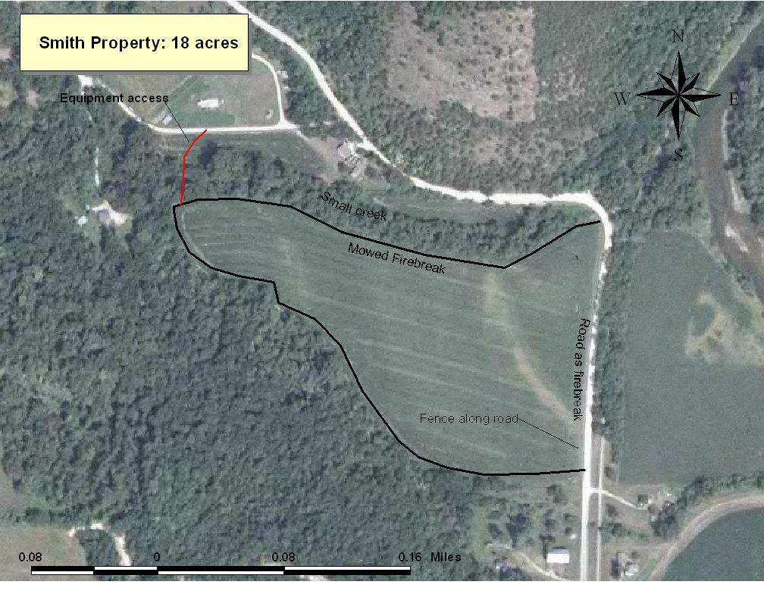

** There is only one access into the field as noted by the red line. There is a 5-strand barbed wire fence along the road, with no opening.

Where to Get a Burn Permit for a Running Fire (Prescribed Burn)

County | DNR Forestry Office | Phone
Dodge | Preston DNR Forestry Office  912 Houston St NW  Preston, MN 55965 | (507) 765-2740
Fillmore | Preston DNR Forestry Office  912 Houston St NW  Preston, MN 55965 | (507) 765-2740
Freeborn | Preston DNR Forestry Office  912 Houston St NW  Preston, MN 55965 | (507) 765-2740
Goodhue | Lake City DNR Forestry Office  1801 S. Oak St  Lake City, MN 55041 | (651) 345-3216 x 242
Houston | Caledonia DNR Forestry Office  603 N Sprague St, Ste 2  Ag Service Center  Caledonia, MN 55921 | (507) 724-5264 ext 5
Mower | Preston DNR Forestry Office  912 Houston St NW  Preston, MN 55965 | (507) 765-2740
Olmsted | See Winona
Rice | Faribault DNR Forestry Office  1810 30th St NW  Faribault, MN 55021 | (507) 333-2012
Steele | Faribault DNR Forestry Office  1810 30th St NW  Faribault, MN 55021 | (507) 333-2012
Wabasha | Lake City DNR Forestry Office  1801 S. Oak St  Lake City, MN 55041 | (651) 345-3216 x 242
Winona | Lewiston DNR Forestry Office  PO Box 279  Lewiston, MN 55952 | (507) 522-5064

* You may be able to get a permit from your local fire warden or sheriff, but not all issue burn permits for running fires. For burns less than one acre, you can get a permit on-line for a $5 fee at the following website: http://webapps1.dnr.state.mn.us/burning_permits/

Prescribed Burn Checklists

Checklist for of things to do BEFORE you burn
Develop your burn plan
Make sure your burn breaks are prepared
Get a burn permit for a running fire
Set a tentative date for your burn: ____________
Reserve the equipment: Barb/Walt (507) 285-0496
Recruit volunteers and a burn boss (see “Calling Volunteers” Checklist below)
Let neighbors know you will be burning

Checklist for Calling Volunteers
Burn date & time: __________________
Estimated duration of burn: __________
Acreage and Terrain of your burn
Location and directions
Your phone number
Remind people to wear natural fiber cotton clothing or wool, a long sleeved shirt, leather boots, leather gloves, bandana, eye protection, and a hat, and to bring portable drinking water.
No polyester or fleece because the fire will melt it onto your skin producing a bad burn.

Checklist for things to do the DAY OF your burn
Check the weather
Activate your burn permit. Permit activation number: _____________________
Make sure equipment is ready, bladderbags are full, torches are full, etc.
Have refreshments, water at a minimum
When crew arrives, check for proper clothing
Determine crew details (ie. experience level, asthma, heart condition, leave early, can’t carry bladderbag, etc). Use this info to assign crew members and tasks to each fire line.
Review the burn plan with your crew and make sure each understands his/her assignment
Go over radio communication
Conduct a test fire, then start to burn
Make sure burn is completely out before leaving the site
Call dispatch to let them know the burn is completed.

Burn Permit Activation and List of Contacts for Notification Prior to Lighting a Prescribed Fire

Activating your Burn Permit

For your burn permit to be valid, you must activate it by either calling the 1-800 number on the permit or going to the website listed on the permit. You will be given an activation number that makes your permit valid. You must activate your permit the day of the burn, after 8am. When you call dispatch, you should give them your activation number. Please note, this is a new procedure that was instituted in 2009.

Who to Notify Prior to a Burn
You are responsible for contacting the DNR Forestry Office and Law Enforcement Dispatch prior to conducting your prescribed burn. Even though your permit registers on an electronic system when you activate it, most County Dispatches want you to call prior to your burn.

County | DNR Forestry | Dispatch | Local Fire Depts.
Dodge | (507) 206-2835 - Rochester Office | (507) 635-6200  Don’t have to call prior to burn
Fillmore | (507) 765-2740 - Preston Office | (507) 765-3874  Don’t have to call prior to burn | Rushford Volunteer Fire Dept., Paul Corcoran (507) 459-6793
Freeborn | (507) 765-2740 - Preston Office | (507) 377-5205 ext 5
Goodhue | (651) 345-3216 ext 242 - Lake City Office | (651) 385-3155  Don’t have to call prior to burn | Red Wing Fire Dept. (651) 388-7141
Houston | (507) 724-5264 ext 5 - Caledonia Office | (507) 725-3379 ext 1  Don’t have to call prior to burn
Mower | (507) 765-2740 - Preston Office | (507) 437-9400 ext 1
Olmsted | (507) 765-2740 - Preston Office | (507) 285-8963 | (507) 285-8963 - Rochester Fire Dept. Dispatch
Rice | (507) 333-2012 - Faribault Office | (507) 334-4391
Steele | (507) 333-2012 - Faribault Office | (507) 451-8233
Wabasha | (651) 345-3216 ext 242 - Lake City Office | (651) 565-3361
Winona | (507) 522-5064 - Lewiston Office | (507) 457-6368  Don’t have to call prior to burn | (507) 458-5495 – Richard Lueck
Updated October 2015

- You should call Dispatch upon completion of your burn (meaning all fire and smoke is gone) to let them know your fire is complete in case they get calls regarding another fire in your area.

